SQL Assignment 5

Relational and Logical Operators

Q1) Write a query that will give you all orders for more than Rs. 1000.



Q2) Write a query that will give you the names and cities of all salespeople in London with a commission above .10



Q3) Write a query on the customers table whose output will exclude all customers with a rating <=100, unless they are located in rome.


Q4) What will be the output from the following query?

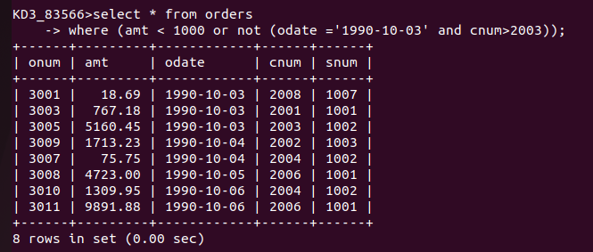

The output of above query is that it will not print the rows whose date is 1990-10-03 and cnum is greater than 2003.

Q5) What will be the output of the following query?

